

CP Lab-11 Tasks

Name: Syed Muhammad Raza Ali

Enrolment: 02-134231-028

Course: CP Lab

Faculty: Miss Fatima

**Lab 11 String**

**Tasks: 01**

Write a structure named triangle which has 3 points p1 , p2 and p3, program takes input and determines if it is a right-angle or not.

Note: A right triangle is [triangle](https://mathworld.wolfram.com/Triangle.html) with an [angle](https://mathworld.wolfram.com/Angle.html) of  90 degree. The sides a, b, and c of such a [triangle](https://mathworld.wolfram.com/Triangle.html) satisfy the [Pythagorean theorem](https://mathworld.wolfram.com/PythagoreanTheorem.html).

$c^{2}=a^{2}+b^{2}$

Code:

#include <iOStream>

#include <string>

using namespace std;

int main() {

struct triangle {

int p1, p2, p3;

};

triangle obj;

cout << "Enter Point 1" << endl;

cin >> obj.p1;

cout << "Enter Point 2" << endl;

cin >> obj.p2;

cout << "Enter Point 3" << endl;

cin >> obj.p3;

if ((obj.p1 * obj.p1) == (obj.p2 * obj.p2) + (obj.p3 * obj.p3) ||

(obj.p2 * obj.p2) == (obj.p1 * obj.p1) + (obj.p3 * obj.p3) ||

(obj.p3 * obj.p3) == (obj.p1 * obj.p1) + (obj.p2 * obj.p2)) {

cout << obj.p1 << " " << obj.p2 << " " << obj.p3 << " are points of a right angeled triangle" << endl;

}

else {

cout << obj.p1 << " " << obj.p2 << " " << obj.p3 << " are not points of a right angeled triangle" << endl;

}

return 0;

}

Output (if points are of a right triangle):

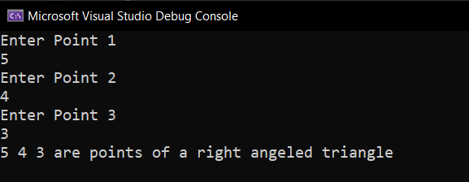

Output (if points are of a right triangle):

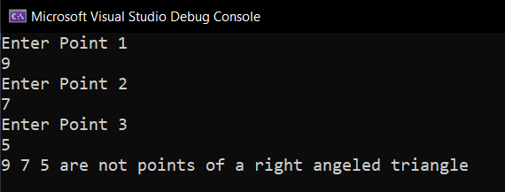

**Tasks: 02**

Make a structure BookRec which stores the following details of a book: title of the book. Author’s name , it’s publisher and price .Write a program to take input of 3 books and display it on console.

Example:

Title: Starting Out with C++

Author: Addison Wesley

Publisher: Tony Gaddis

Price: $150.00

Code:

#include <iOStream>

#include <string>

using namespace std;

int main() {

struct bookRec {

string title;

string author;

string publisher;

float price;

};

bookRec obj[3];

for (int i = 0; i < 3; i++) {

cout << "Enter the title of the book" << endl;

cin >> obj[i].title;

cout << "Enter the author of the book" << endl;

cin >> obj[i].author;

cout << "Enter the name of the publisher" << endl;

cin >> obj[i].publisher;

cout << "Enter the price of the Book" << endl;

cin >> obj[i].price;

}

for (int i = 0; i < 3; i++) {

cout << endl << "***********" << endl;

cout << "Title: ";

cout << obj[i].title << endl;;

cout << "Author: ";

cout << obj[i].author << endl;

cout << "Publisher: ";

cout << obj[i].publisher << endl;

cout << "Price: $";

cout << obj[i].price << endl;

}

return 0;

}

Output :

Output (if not a palindrome):

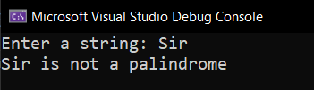

**Tasks: 03**

Write a program that compare two strings and prints the shorter one. It prints equal if both strings are same.

Code:

#include <iostream>

#include <string>

using namespace std;

int main() {

string word1, word2;

cout << "Enter a sting" << endl;

cin >> word1;

cout << "Enter another string " << endl;

cin >> word2;

int a = word1.length();

int b = word2.length();

if (a == b) {

cout << "both string have equal lengths " << endl;

}

else if (a > b) {

cout << word1 << " has bigger length than " << word2 << endl;

}

else {

cout << word2 << " has bigger length than " << word1 << endl;

}

return 0;

}

Output:

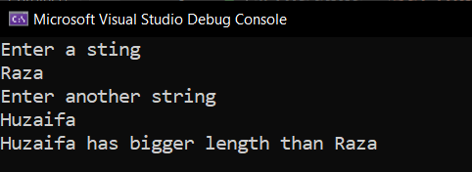

**Tasks: 04**

Write a program that takes a string as an input and copies it another empty string and displays it.

Code:

#include <iostream>

#include <string>

using namespace std;

int main()

{

string string1 ;

string string2 = "";

cout << "Enter a string: " ;

getline(cin, string1);

cout << "string1 before copying = " << string1 << endl

<< "string2 before copying = " << string2<<endl;

string2 = string1;

cout << "string1 after copying = " << string1 << endl

<< "string2 after copying = " << string2<<endl;

return 0;

}

Output:

